Report on water body identification in the Saxonian part of the German River Neisse Basin

Author: Dr. Petra Podraza & Martin Halle (umweltbüro essen), Dr. Heiko Sieker (Ingenieurgesellschaft Prof. Sieker);
Pilot River basin leader: Dr. Bernhard Fritzsche (StUFA Bautzen)

PRB Neisse (Germany, Czech Republic, Poland)

Date of submission: 30/09/2003

1 Characteristics of the catchment
The Lausitzer Neisse is one of major tributaries of the Odra River. The River basin is located in three national states: Germany, Czech Republic, and Poland (Map 1)
.
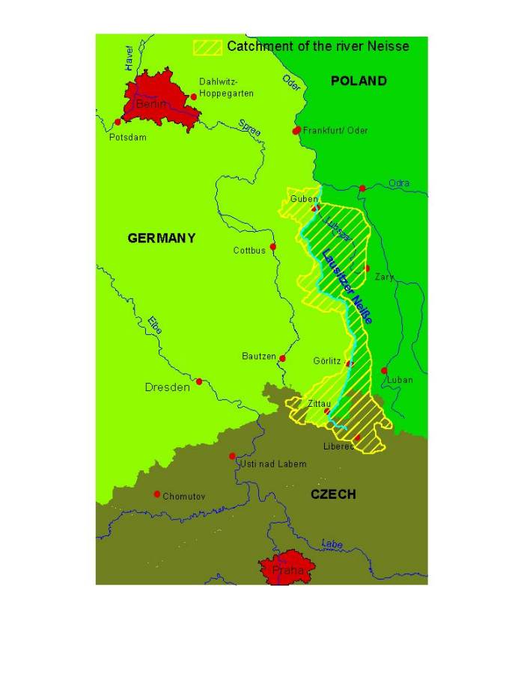

Map 1: Catchment of the Lausitzer Neisse

 | Czech Republic | Germany | Poland | Sum
Catchment | 455 km² | 1,411 km² | 2,537 km² | 4,403 km²
Neisse River length | 55.6 km | 199 km |  | 254.6 km
length of tributaries |  | 1,229 km

In Germany the major part of the river belongs to the federal state Saxony (Neisse River length: 124.8 km). The most important tributaries in Saxony are the Mandau River (catchment: 297 km², river length: 27.43 km) and the River Pliessnitz (catchment: 164 km², river length: 29.34 km.

Methods and results of the water body identification process
Differing from the way of water body identification realized by the federal state of Saxony (not yet completed), the German consulting team tried to follow the guidelines of the ‘Horizontal guidance document on the application of the term „water body“, using the flowchart (fig 1), presenting a proposal on water body identification. The ground water body identification was already done by the federal states of Saxony and Brandenburg and will be used in this project on CIS guidance document testing.

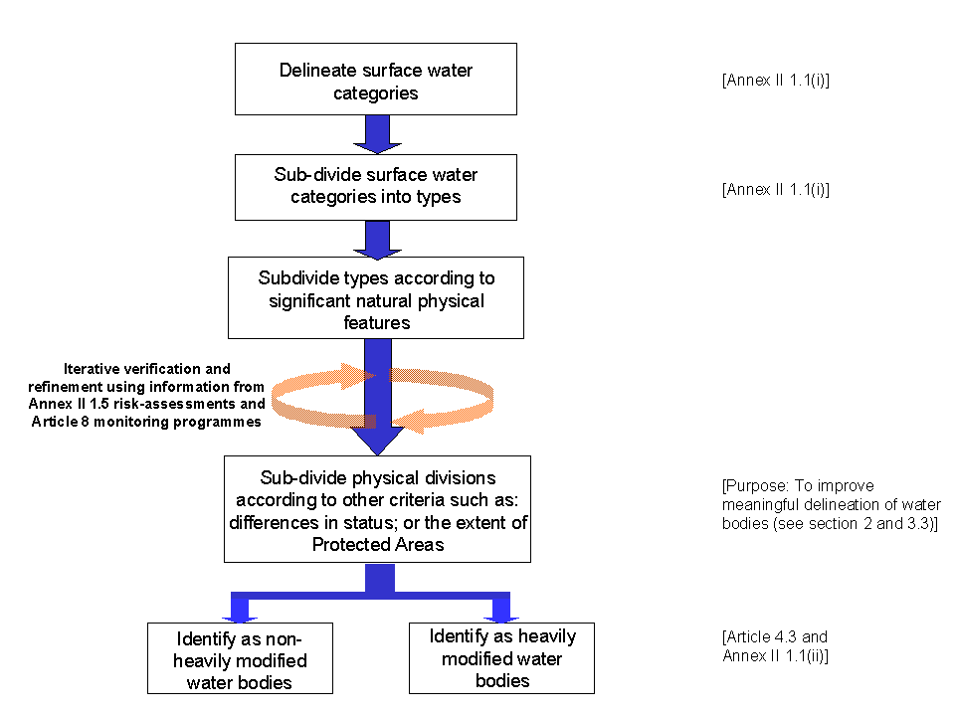

Fig. 1: Flow chart on the water body identification process (from ‘Horizontal guidance document on the application of the term „water body“)

  - Water category (surface water bodies)
In the Saxonian part of the Lausitzer Neisse basin the surface waters are "rivers" and "lakes" (Map. 2)

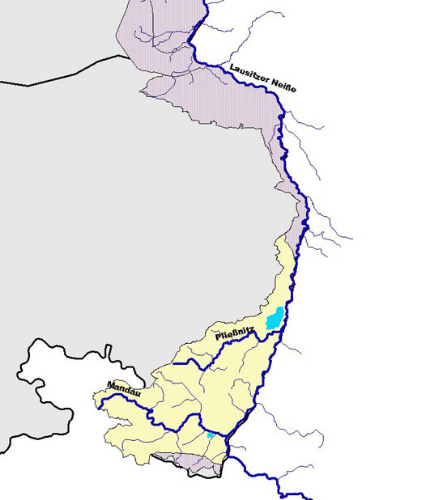
Map 2: Surface waters in the Saxonian part of the Lausitzer Neisse Basin (DGM 100).

    - Lakes
In the Saxonian Lausitzer Neisse Basin, there are two lakes with a surface area > 0.5 km²: Berzdorfer See (8.3 km²) and Olbersdorfer See (0.7 km²). Smaller lakes like fish ponds or retention basins are not considered here.

2.1.2 Rivers
In the Saxonian part of the Neisse basin all rivers are natural, not man-made "artificial water bodies". Although there are impoundments in the Lausitzer Neisse and its tributaries, the stagnant water upstream the weir is smaller than 0.5 km², so they are not considered as a new water body of a different category (= no heavily modified water body due to change in category).

2.2 Typology
    - Lakes
Both lakes should be designated as "artificial water bodies", because there originate from open cast brown coal mining, flooded after brown coal mining abandoned at these locations. To assess the ecological potential of these artificial lakes, they can be compared to natural lakes of the lake type: siliceous stratified Lake in the mountainous region (lake typology following the German LAWA lake typology system) completed with information on the resulting aquatic communities.

    - Rivers
In Germany there is a stream typology system with a stream type map covering the whole country. This system was used identifying the water bodies. The German stream typology uses elements of system A as well as elements of system B. The German stream type system is basing on a landscape system defined by Dr. Briem considering important hydromorphological and geochemical parameters, describing near-natural (potentially natural) conditions and the resulting aquatic community. The major parameters used, are: ecoregion, catchment size, shape of the valley, slope, meandering form, stream bed substrate, hydrology, hydraulic regime, vegetation, and geochemistry. In the German Lausitzer Neisse basin 8 different stream types out of 23 stream types defined for the German basins can be identified.

Types in the mountainous region
Type 5: | brooks in siliceous mountainous region (s)
Type 9: | mid-sized stream in siliceous mountainous region (s)
Type 9.2: | large river in siliceous mountainous region (k)
Types in the lowland area of northern Germany
Type 14: | sandy lowland brooks (s, k)
Type 15: | lowland mid-sized stream characterized by sand and clay (k)
Type 16: | lowland brooks with gravel (s, k)
Types, not depending on ecoregion
Type 11: | brooks with organic streambed (bog, moor, swamp) (o)
Type 19: | stream in the broad river valley (k)

Map 3 shows the stream types in the River Mandau in the Saxonian part of the Lausitzer Neisse Basin.

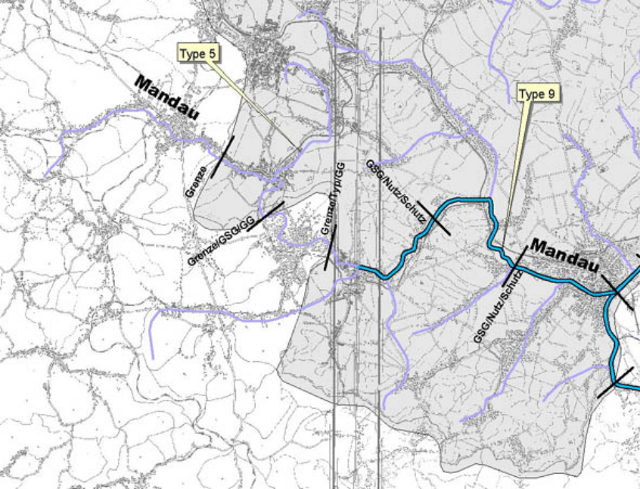

Map 3: Stream types in the River Mandau in the Saxonian part of the Lausitzer Neisse Basin

2. 3 Significant natural physical features
2.3.1 Lakes
With a surface area of 8.3 km² and 0.7 km² both lakes are too small to be divided into more then one water body (e.g. separation of bays). On the other hand they are too different and clearly separated to be aggregated to one water body group.

    - Rivers
Although there are several tributaries of the Lausitzer Neisse with a catchment area larger than 10 km², only the tributaries Mandau River and River Pließnitz as well as the Neisse itself are regarded as significant sub-basins. On the scale of these sub-basins water bodies may me aggregated to water body groups. Following the procedure described above combined with preliminary results from pressure and impact analysis (2.4 "other criteria") the Saxonian part of the PRB Neisse can be delineated into 41 water bodies. In this first delineation step the tributaries with catchment areas smaller than 10 km² were neglected and if necessary regarded as point sources of pollution comparable to industrial discharges. (In Germany the map DGM 1000 W used for WFD implementation only includes rivers with catchment areas > 10 km² and lakes larger than 0.5 km²). Exception: the tributary (< 10 km² or > 10 km²) is significantly affected by human activity. (This will be decided after the detailed pressure and impact analysis). In this case the tributary will be identified preliminary as a single water body with no good ecological and / or chemical status. After realizing the measures to reach the good ecological and chemical status, the water body will be deleted and the tributary will be ignored again (because of small size and minor importance) or it will be part of the water body group again (=> iterative process in water body identification)

2.4 Other criteria
The German consulting team IPS & ube uses criteria of the "pressure and impact analysis" as well as information on natural reserves (e.g. FFH areas) as "other criteria" separating water bodies. This was only done for the water bodies of category "river". Though in Germany most of the rivers are assessed by their saprobic status, indicating organic pollution, this criterion was one of the additional criteria used. The German river habitat survey, indicating the morphological status of the rivers, is also available for most of the German rivers. Both assessment systems base on a classification system with 7 different classes, visualized in a map by different color stripes along the rivers.

Quality class
Saprobic System | River Habitat Survey | Status in accordance with the WFD | Color
I | 1 | high | dark blue
I-II | 2 | high | bright blue
II | 3 | good | dark green
II-III | 4 | moderate | bright green
III | 5 | poor | yellow
III-IV | 6 | bad | orange
IV | 7 | bad | red

Land use in the catchment was also used as additional criteria for water body identification. To use this parameter, we aggregated the detailed information on land use to the following utilization parameters:
- forest
- grassland
- field
- urban area
- industry
- mining area
- water
The results of both assessment systems for the River Mandau in the Saxonian part of the Lausitzer Neisse Basin are shown in map 4 and 5.
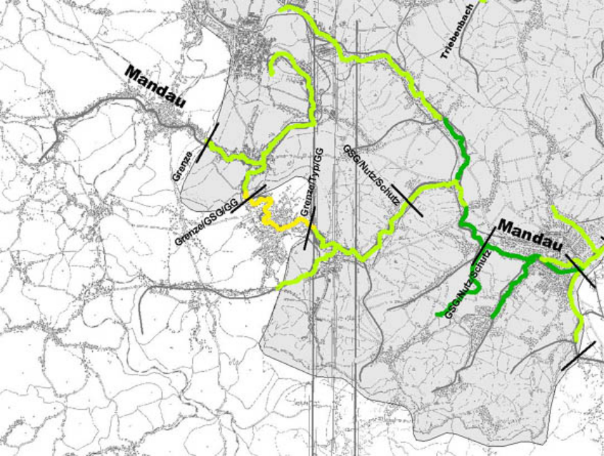

Map 4: Saprobic quality classes in the River Mandau

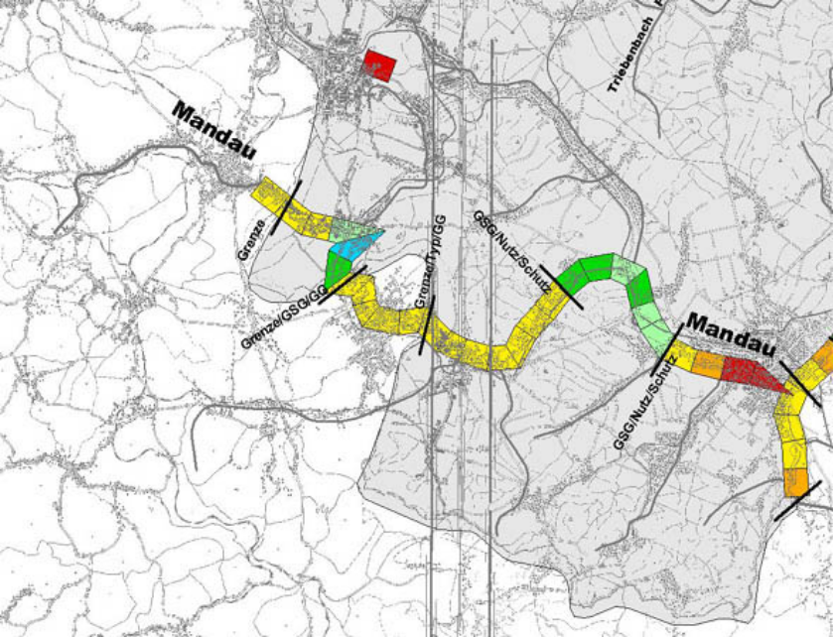

Map 5: German River Habitat Survey in the River Mandau

Map 6 shows the FFH reserves in the catchment of the River Mandau.

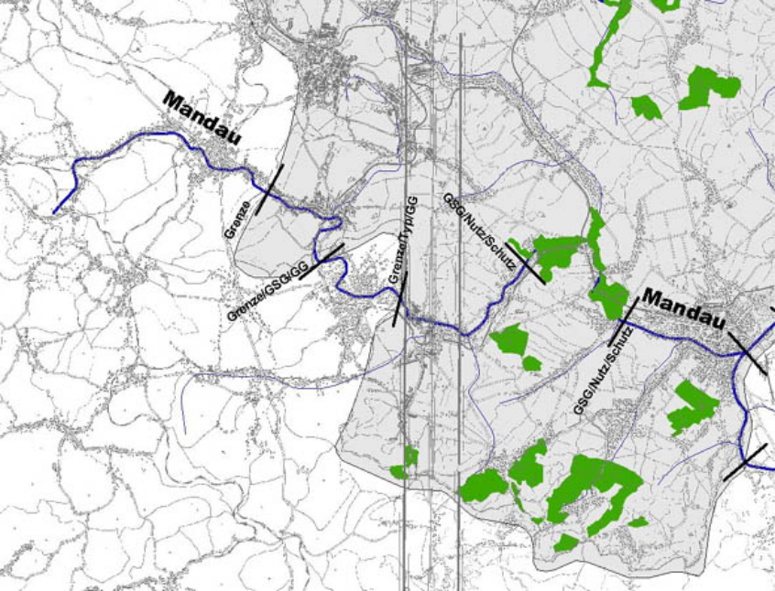

Map 6: FFH-reserves in the Mandau catchment

Map 7 shows the land use classes in the Mandau sub-basin.
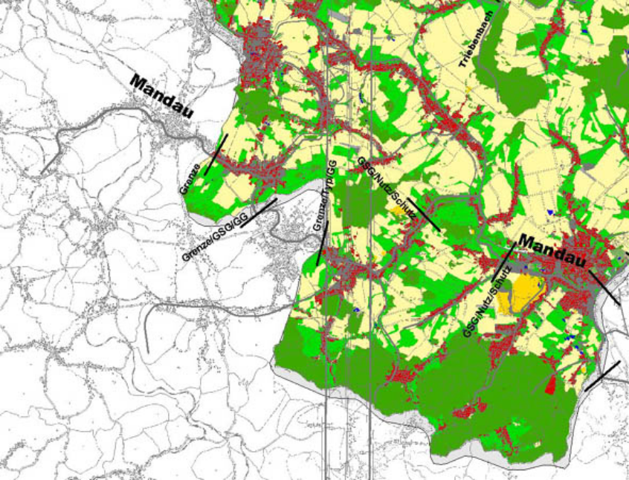

Map 7: Use classes in the Mandau sub-basin

Using all these informations a delineation of the River Neisse Basin into many very small water bodies would be possible. Not to get too small water bodies in the range of some hundred meters, which are neither useful for the reporting scale nor for management purposes, we decided which possible reasons for delineations are most important. This was necessary because of very local changes in land use and morphological structure (=> German habitat survey with information in 100 m scale). The decision on the hierarchy of reasons for water body identification wasn't done automatically but by expert judgment. We aim to define water bodies as homogenous (concerning typology, pressures and impacts) and as big as possible with a minimum size limit of ~ 2 km. As a result the mean water body size in the Saxonian part of the PRB L. Neisse ranges between 6 and 7 km.
If a water body is not really homogenous in its pressures and impacts and a delineation into two parts would result in at least 1 water body of significantly less than 2 km, we divided the water body into homogenous sub-water bodies to keep the information for the monitoring and the management program.

In general we conclude: the larger the river is, the larger should be its water bodies. Reason: a water body should be homogenous in its ecological status, indicated by the given biological parameters. Minor differences in impact intensities (point sources of pollution, morphological structure) won't affect the biological communities in large rivers. In contrast the same differences in impact intensities will cause severe changes in the ecological status of small rivers. => water bodies being homogenous in the quality of the biological communities (but not always homogenous in impacts) can be larger in large rivers than in small ones.

The resulting number of 41 water bodies in the Saxonian part of the Neisse catchment is far too large to be monitored or managed individually. So in every discrete sub-basin (here: Neisse, Mandau River, River Pließnitz) we intend to aggregate tributary water bodies being homogenous in
- category
- stream type
- impact
to water body groups. We assume that for monitoring in most cases only one representative location per homogenous water body group should be sufficient. Only in case of large distances and uncertain homogeneity more monitoring sites will be necessary.

Results for the Saxonian part of the Neisse Basin:

 | Watershed Neisse  (excl. Mandau & Pließnitz) | Watershed Mandau | Watershed Pließnitz
Number of water bodies | 20 | 12 | 9
mean size of water bodies | 6.9 km | 6.4 km | 6.5 km
max. size of water bodies | > 30.0 km | 13.5 km | 20.0 km
min. size of water bodies | 2.4 km | 2.0 km | 2.1 km

Compared to the practice of water bodies identification in most German federal states the stringent application of the "horizontal guidance document" - as done in the German pilot river basin of the L. Neisse - produces significant more and smaller water bodies in the first iteration state of the whole identification process. Whether this is a problem or an advantage has to be proved when the following steps are completed.

In any case it shall be stressed that:

- following iteration steps still allow the aggregation of water bodies if the ecological status should prove more homogenous as presumed in the first delineation step.
- aggregation of water bodies into water body groups is a very useful and efficient possibility for the purpose of monitoring as well as for the river basin management.

